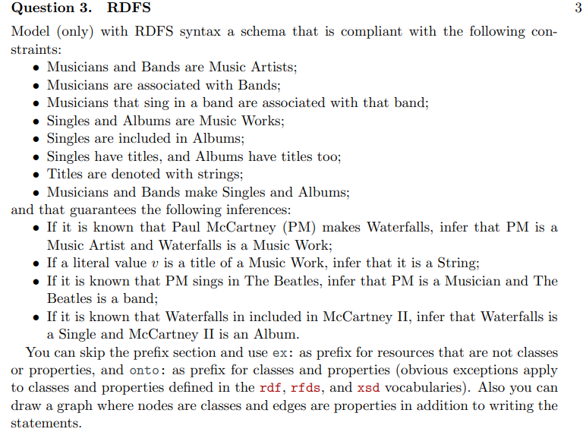

• Musicians and Bands are Music Artists;

onto:Musician rdfs:subClassOf onto:MusicArtist.

onto:Bands rdfs:subClassOf onto:MusicArtist.

• Musicians are associated with Bands;

onto:associatedWith rdfs:domain onto:Musicians;

rdfs:range onto:Bands

• Musicians that sing in a band are associated with that band;

onto:singIn rdfs:subPropertyOf onto:associated.

• Singles and Albums are Music Works;

onto:Singles rdfs:subClassOf onto:MusicWork.

onto:Albums rdfs:subClassOf onto:MusicWork.

• Singles are included in Albums;

onto:includedIn rdfs:domain onto:Singles;

rdfs:range onto:Albums.

• Singles have titles, and Albums have titles too;

onto:haveTitles rdfs:domain onto:MusicWork;

rdfs:range xsd:string.

• Titles are denoted with strings;

• Musicians and Bands make Singles and Albums;

onto:make rdfs:domain onto:MusicArtist;

rdfs:range onto:MusicWork.

onto:make rdfs:domain onto:MusicArtist ; rdfs:range onto:MusicWork .

and that guarantees the following inferences:

• If it is known that Paul McCartney (PM) makes Waterfalls, infer that PM is a Music Artist and Waterfalls is a Music Work;

• If a literal value v is a title of a Music Work, infer that it is a String;

• If it is known that PM sings in The Beatles, infer that PM is a Musician and The Beatles is a band;

• If it is known that Waterfalls in included in McCartney II, infer that Waterfalls is a Single and McCartney II is an Album.

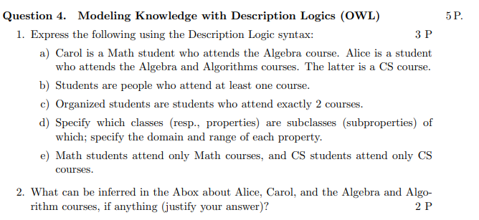

a) Carol is a Math student who attends the Algebra course. Alice is a student who attends the Algebra and Algorithms courses. The latter is a CS course.

MathStudent(carol).

student(carol).

attend(carol, Algebra).

course(Algebra).

student(alice).

attends(alice, Algebra).

attends(alice, Algorithms).

Course(Algortims).

b) Students are people who attend at least one course.

student = people ∏ ∃attend.course.

c) Organized students are students who attend exactly 2 courses.

organisedStudent = stuent ∏ ( =2 attend.courses).

d) Specify which classes (resp., properties) are subclasses (subproperties) of which; specify the domain and range of each property.

* student subclass of people.
* MathStudent subclass of student.
* organisedStudent subclass of student.
* attend domain student, attend range course.
* MathCourse subClass of Course

e) Math students attend only Math courses, and CS students attend only CS courses. 2.   
mathStudent = ∀attend.mathCourse.

CSStudents = ∀attend.CSCourse.

What can be inferred in the Abox about Alice, Carol, and the Algebra and Algorithm courses, if anything (justify your answer)?